AUTOMATED TEST EXECUTION & REPORTING FRAMEWORK
Project Flow & Scope Document

1. Project Title
Automated Test Execution & Reporting Framework for BCM Door Lock Function
2. Project Description
This project is a simple automotive automation framework developed using Python.
The framework simulates the working of a Body Control Module (BCM) for Door Lock and Door Unlock operations.
This project focuses on validating the Door Lock functionality in the Body Control Module (BCM) ECU. The framework automates execution of predefined test cases
The test cases are stored in an Excel file.
Python reads the test cases automatically, executes the logic, compares expected and actual results, and generates:
• Log file • Report file • Pie chart analysis
3. Objectives
• To automate BCM Door Lock testing
• To read test cases from Excel
• To generate automatic test reports
• To create log files for execution tracking
• To display graphical analysis using charts
4.Project Members
- Gusain Shubham
- Hande Omkar
- Mohamed Ijaz
5. Technologies Used
• Python – Programming
• Pandas – Reading Excel file
• OpenPyXL – Excel support
• Matplotlib – Pie chart generation

6. Software Requirements
• Python 3.x • VS Code • Excel

7. Flowchart

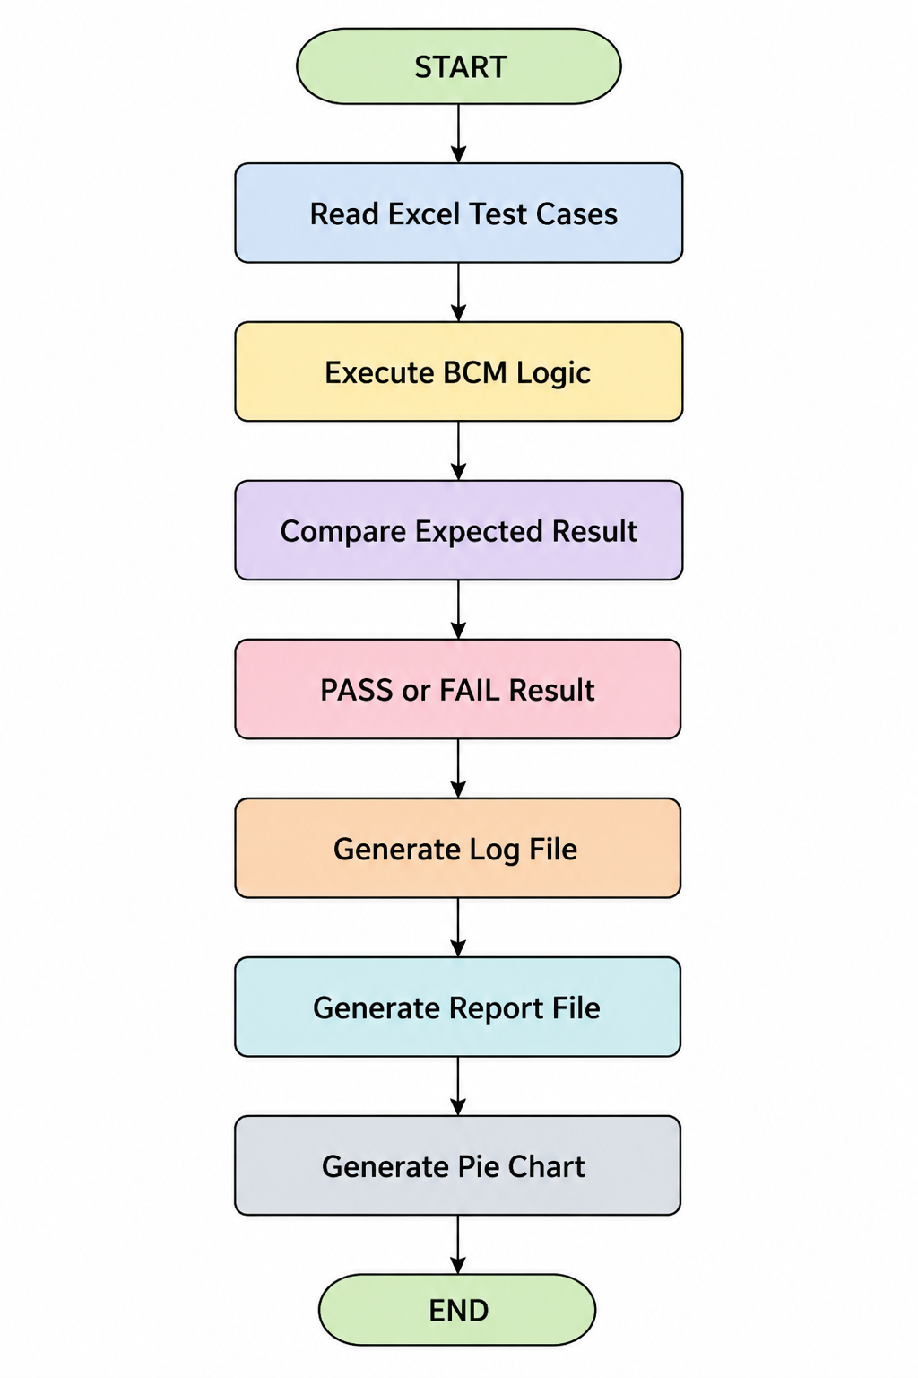

8. Advantages
• Easy to understand
• Beginner-friendly
• Simple automation framework
• Reduces manual testing effort
• Generates automatic reports
9. Conclusion
The BCM Door Lock Automation Framework successfully automates Door Lock and Unlock validation using Python.
The framework reads test cases from Excel, executes them automatically, stores logs, and generates reports with graphical analysis.
This project provides a basic understanding of automation testing concepts used in the automotive domain.

